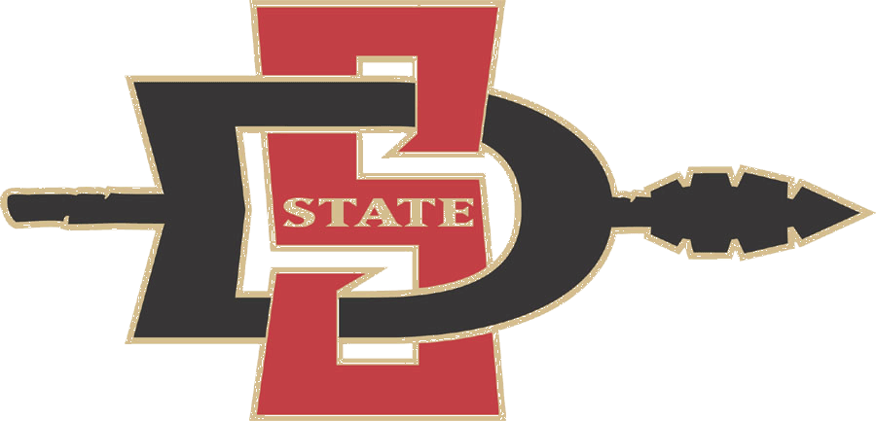

Physical Activity during Youth Sports Practices

Summary of Published Paper

Leek, D., Carlson, J.A., Cain, K.L., Henrichon, S., Rosenberg, D., Patrick, K., and Sallis, J.F. (2011). Physical activity during youth sports practices. Archives of Pediatrics and Adolescent Medicine. Published online December 6, 2010; print version April 2011.

Background

National guidelines state that children and adolescents should accumulate 60 minutes of moderate to vigorous physical activity (MVPA) each day. Fewer than 50% of children and 10% of adolescents are meeting these guidelines. Sports participation is one way to youth can engage in MVPA to count towards meeting guidelines. In the United States, an estimated 44 million youth participate in organized sports. However, it is not clear how much physical activity is provided by youth sports.

Data collection

103 youth from a recreational soccer league and 97 youth from a recreational baseball/softball league were randomly selected to wear an objective physical activity monitor (Actigraph accelerometer) during a practice session. The leagues were located in San Diego, CA and varied in skill level. Of the 200 youth, 17% were White/non-Hispanic, 72% were Latino/Hispanic, 40% were classified as overweight, and 73% came from a household with an annual income ≥ $50,000.

Results
- Practice time ranged from 35 to 217 minutes and was 104 minutes on average.
- Overall, 24% of participants met the 60 minute MVPA guideline during practice, but fewer than 10% of participants aged 11-14 and 2% of softball players met the full 60 minute MVPA guideline.
- On average, youth spent 45 minutes in MVPA.
- Soccer players spent an average of 15 more minutes in MVPA than baseball/softball players.
- Boys spent an average of 10 more minutes in MVPA than girls.
- Youth ages 7-10 spent an average of 10 more minutes in MVPA than girls.

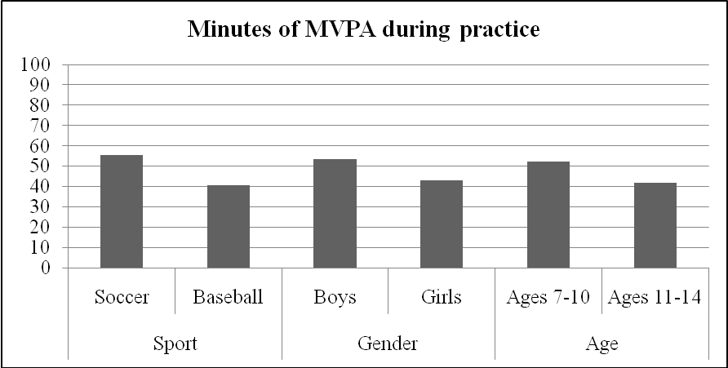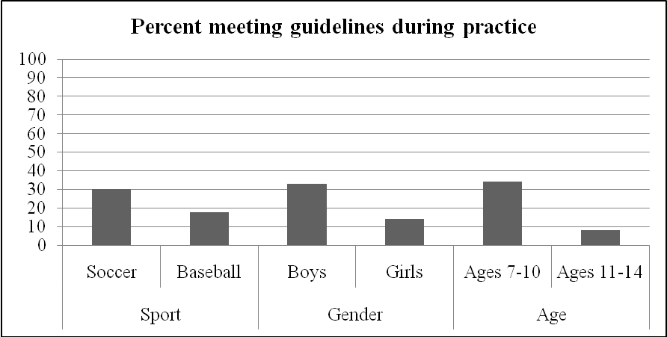

Conclusions
The childhood obesity epidemic makes it imperative for all sectors of society to get engaged in increasing youth physical activity. Youth sports have the potential for large public health impact given the millions of participants, length of seasons, and years of participation. Though youth sports contribute to overall physical activity and provide additional benefits, the present study documented that less than one fourth of youth athletes obtained the recommended 60 minutes of MVPA during sports practices. Thus, organized sports participation is not sufficient to ensure youth meet recommendations on practice days. Baseball/softball players, girls, and older youth (11-14 years) accumulated significantly fewer MVPA minutes and were much less likely to meet guidelines than soccer players, boys, and younger players (7-10 years). Girl softball players had particularly low activity levels. Surprisingly, youth sports players were inactive about 30 minutes during the average practice.. Based on current findings it appears that youth sports practices are making a less-than-optimal contribution to the public health goals of increasing physical activity and preventing childhood obesity. Ensuring that all youth are active enough will require the combined efforts of parents, schools, governments, youth-serving agencies, as well as youth sports organizations.

Recommendations for Maximizing Physical Activity in Youth Sports
- Adopt policies and practices that ensure youth obtain sufficient physical activity during practices.
- Emphasize participation over competition.
- Sponsor teams for all skill levels across all ages.
- Ensure access by lower-income youth with sliding scales for fees.
- Increase practice frequency and extend short seasons.
- Monitor physical activity periodically during practices.
- Train coaches to use strategies that increase physical activity.
- Support youth and parents in obtaining adequate physical activity on non-practice days.

